Problem Chosen  D | 2020  MCM/ICM  Summary Sheet | Team  Control Number  2005895

Summary
In order to explore team performance in soccer teams, we established a model to evaluate a team’s competitiveness and gave the coach advice to make the team better.
Firstly, we built a network of the players’ passing route, showing the times of Huskies’ players passing the ball. From the network we established pattern data, including dyadic and triadic configurations and crucial chain between players. Another chart shows how players move during a match and the route of ball passing.
Then, we analyzed the data of 38 matches and found some patterns of the Huskies’ strategies, including structural tactics, such as counter attack and frequently short pass. These patterns indicate the ability of attacking and defending. Several charts are made to figure out the structure vividly. Team formation is also discussed in detail. In addition, side data and results of confronting with the same opponent for the second time are calculated.
Through the statistics, we identified some indicators to evaluate a team’s performance, consisting of player ability, collaboration and crucial chain, flexibility, mentality and team formation.
We established a model to evaluate the performance of a team during a soccer match. There are three aspects to be evaluated: structural aspect, configurational aspect and dynamical aspect. Structural aspect includes the ability of players in different positions, assessed by pass and duel ability, as well as contribution to crucial chains. Configurational aspects are structural tactics and team formations, assessed by the used times of tactics and the win rate of different team formation. In addition, the ability of team members is a significant part in a soccer team. Dynamical aspect is consisted of flexibility and mentality, estimated by win and loss rate when the players confronting with various opponents at different places.
We estimated the abilities of Huskies and other 19 teams, ranked them through the three aspects above, by which we gave the coach several suggestions to improve the team’s performance.
At last, we extend the model to other kinds of teams in society, adding new aspects to evaluate different teams, through which we can learn how to form an efficient team. Then we give team leadership specific suggestions to make their team work more efficiently.

Content
1. Introduction 3
1.1. Restatement of the Problem 3
1.2. Assumptions 3
1.3. Flow Chart 4
2. Notations 5
3. Data Analysis 6
3.1. Create Passing Network 6
3.2. Pattern Data 7
3.2.1. Dyadic Configurations 7
3.2.2. Triadic Configurations 7
3.2.3. Crucial Chain 8
3.3. Create Position Network 9
3.4. Pass Data 9
3.5. Team Formations 11
3.6. Side Data 12
3.7. Same Opponent Data 12
3.8. Structural Tactics 12
4. Identify Indicators 14
4.1. Player Ability 14
4.2. Collaboration & Crucial Chain 14
4.3. Tactics 15
4.4. Flexibility 15
4.5. Mentality 15
4.6. Team Formation 15
5. Model 15
5.1. Structural Aspect 16
5.2. Configurational Aspect 17
5.3. Dynamical Aspect 17
6. Teamwork Evaluation 17
6.1. Result of Three Aspects for Huskies 17
6.2. Suggested Formation 20
6.3. Advice to Coaches 21
7. Team in Society 22
7.1. Indicators 22
7.2. Other Aspects and Indicators 22
7.3. Advice to Team Leadership 23
8. Evaluation and Promotion of Our Model 23
8.1. Strengths 23
8.2. Weaknesses and Promotion 23

Introduction

Restatement of the Problem
Soccer team is a typical type of a team. In a soccer team, players can get the most out of their soccer skills when team members corporate well with each other in order to win a game.
Networks are built to show how the ball pass between players, through which network patterns are identified, especially the collaborations on a small scale, such as dyadic and triadic configurations. Some other indicators are identified to describe a team’s strategies.
Performance indicators are identified to reflect their teamwork in three aspects: structural, configurational and dynamical aspects. Through the aspects an evaluation model is built. The model is used to evaluate a team’s performance and the matches’ process.
With the model, we can evaluate a team’s ability and give the coaches advice to improve their performance.
Teams in other fields are similar to a soccer team. A team’s success depends on every member’s abilities and hard work, several team members’ cooperation and the team’s cohesive force. More aspects should be added to a complex team in various fields.

Assumptions
- Every team try their best to win the game or the rank of themselves or their opponent. No player intentionally play badly.
- All the games share the same half-time. 2700 seconds each half and any events occurred after 2700 second is ignored. The reason is the number of events only account for less than 5% of all events.
- When a team take part in a game, they are energetic, not fatigued. No player is in illness.
- Weather does not influence the match. Because weather data is not provided.
- The judge is always fair for both team no matter whose side is home or away.

Flow Chart
The complete flow chart of the paper is shown below:
Figure 1 : Flow Chart
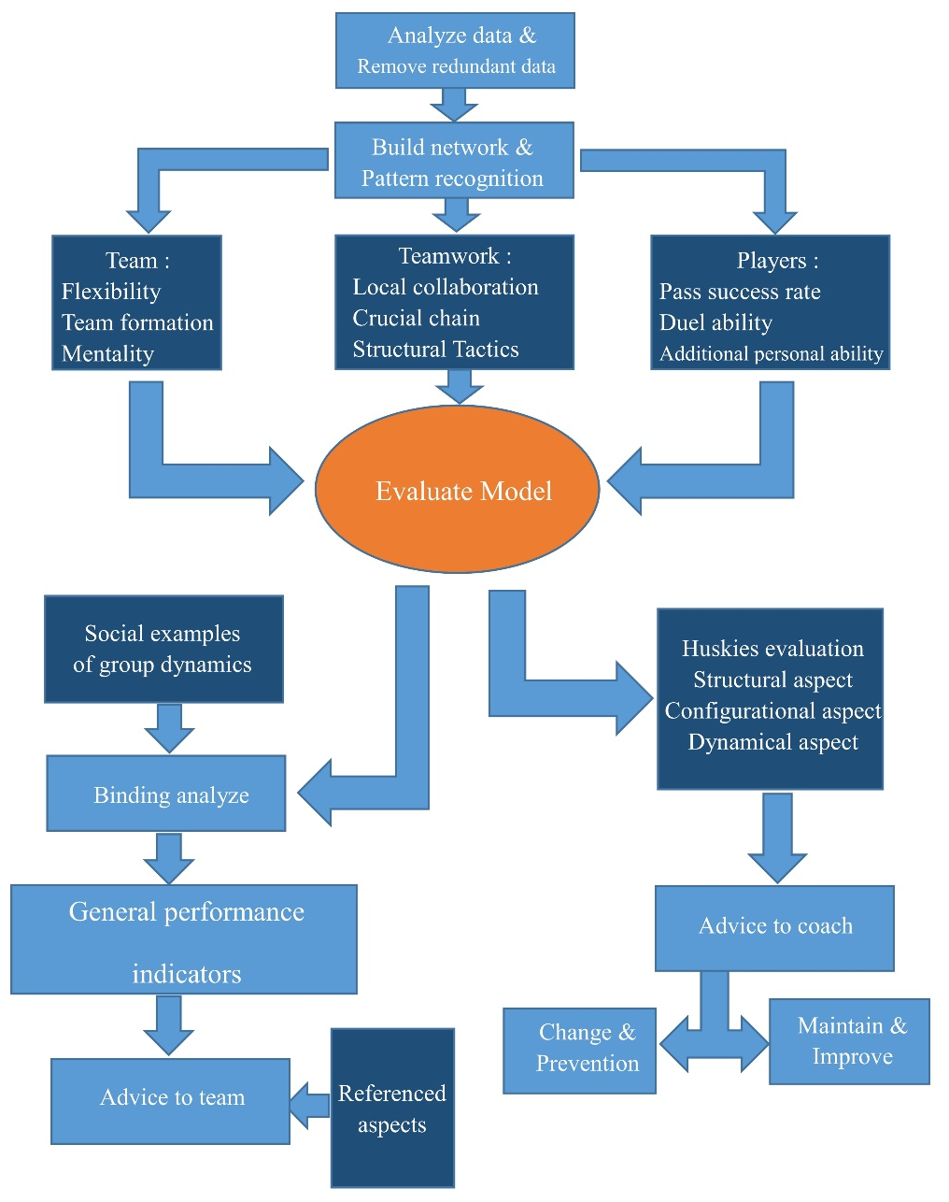

Notations
Denote the list of twenty teams $S=\{h,x|x∈[1,19]\}$, the list of constants and the variables are as following.

Table 1: $S$ List
Constant | $$h$$ | $$x$$
Team | Huskies | Opponent$x$

Table 2: Constants and variables
Constant | Clarification
$$m$$ | Particular match, $m∈[1:38]$
t | Particular team, $i∈S$
$$p$$ | Particular player, $∃i∈S,p∈i$
$$T_{p}$$ | The team contains $p$
$$P_{p_{1},p_{2}}$$ | A pass from $p_{1}$ to $p_{2}$
$$C_{x}^{m}$$ | In match m, the count of $x$, m=null refers to whole 38 matches
$$S_{p}^{pass}$$ | The sum of passing events involving $p$
$$S_{p}^{duel}$$ | The sum of dueling events involving $p$
$$S_{p}^{pass_sus}$$ | The sum of passing events involving $p$ where$p$’s team got the ball finally
$$S_{p}^{duel_sus}$$ | The sum of dueling events involving $p$ where$p$’s team got the ball finally
$$R_{p}^{pass}$$ | The rate of$p$’s passing success
$$R_{p}^{duel}$$ | The rate of$p$’s dueling success
$$SA$$ | Structural ability score of a team
CS | Configurational ability score of a team
DN | Dynamic ability score of a team

Data Analysis

Create Passing Network
Table 3 : Example of pass event
Here is an example of passing event in fullevents.csv. First, we record the passer (Huskies_D1) and receiver (Huskies_F1) in all these passing events. Then we establish a directed link connection of the football trajectory between the receiver and the passer in the data. For each pair of teammates, we count the number of their links.
Second, we try to find the average position of all the players in games. We record the position of the passer and the receiver when there are passing events happen between them. And calculate the average position of each player:
$$\left(\overline{x},\overline{y}\right)=\frac{\sum_{i=1}^{n}{\left(x_{i},y_{i}\right)}}{n}$$
$\left(\overline{x},\overline{y}\right)$ is the average position which is calculated from $n$ different recorded positions $\left(x_{i},y_{i}\right)$.
For example, we will record (34, 97) as one position of Huskies_D1, and record (59, 95) as one position of Huskies_F1. The x-coordinate 34 and 59 are oriented from the perspective of the attacking team, where 0 indicates the team's own goal, and 100 indicates the opposition team's goal. The y-coordinate 97 and 95 are oriented from the perspective of the attacking team, where 0 indicates the team's left-hand side, and 100 indicates the team's right-hand side.
Third, we want to find out the crucial chain when team attacks. A chain means a continuous pass path. A crucial chain means a continuous pass path in which the final player has a chance to shoot. We also consider the gate of opponents as a player. The shot event means passing the ball to the gate and the position of gate is always (100, 50).
With position data and passing data, we plot the passing network of the Huskies in the first match as follow:
Figure 2 : Huskies network of first match
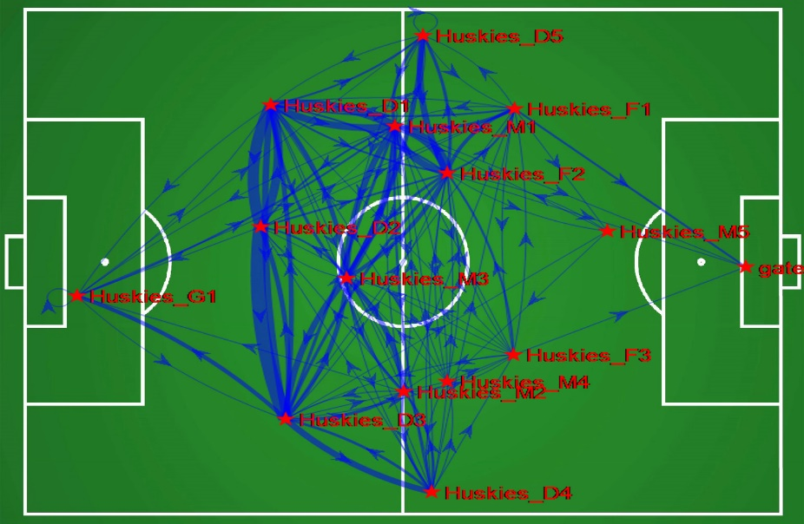
In Figure 2, a red star represents a player. A red word alongside the star is the name of the player. A blue link between a pair of stars refers to the pass path between a passer and a receiver. The star indicated by the arrow is a receiver. The thickness of the links represents the number of the passing events. The thicker the line is, the more the same passing event happens. We can see there are 14 players shown on the figure because in addition to 11 regular players, there are 3 reserve players.
Besides, the networks of all matches and of whole season are also established.

Pattern Data
In this part we introduce the patterns we want to find out from the networks, and the data we dig out from the patterns.
    - Dyadic Configurations
In our passing network, the dyadic pattern refers to the situation that two players pass to each other a lot. To find these patterns we count the number of passing events between all pairs of teammates. Finally, we find the top ten pairs in Huskies:
Table 4 : Top ten dyadic of Huskies
Passer | Receiver | Count | Passer | Receiver | Count
Huskies_M1 | Huskies_F2 | 182 | Huskies_D1 | Huskies_G1 | 107
Huskies_M3 | Huskies_M1 | 168 | Huskies_D1 | Huskies_D3 | 105
Huskies_M1 | Huskies_M3 | 143 | Huskies_D3 | Huskies_D1 | 98
Huskies_D3 | Huskies_G1 | 120 | Huskies_D5 | Huskies_F2 | 97
Huskies_F2 | Huskies_M1 | 117 | Huskies_D1 | Huskies_M1 | 92
    - Triadic Configurations
In soccer, triadic configuration refers to the situation that three players complete a series of cooperation including passing ball to each other and finishing shooting. In the network, we consider a passing path of length 2 as a small triadic cooperation. In other words, if there are two consecutive passes between three players, we will regard these three people as a triadic pattern. And we count the frequency of this kind of cooperation between every three teammates. Top ten Huskies triadic groups are shown below:
Table 5 : Top ten of Huskies triadic group
player1 | player2 | player3 | count | player1 | player2 | player3 | count
Huskies_F2 | Huskies_D5 | Huskies_M6 | 30 | Huskies_F2 | Huskies_D2 | Huskies_D6 | 19
Huskies_F2 | Huskies_M3 | Huskies_D5 | 26 | Huskies_F2 | Huskies_D5 | Huskies_M4 | 18
Huskies_F2 | Huskies_D3 | Huskies_D8 | 23 | Huskies_F2 | Huskies_D3 | Huskies_D4 | 18
Huskies_F2 | Huskies_M3 | Huskies_D4 | 23 | Huskies_F1 | Huskies_M1 | Huskies_F2 | 18
Huskies_F2 | Huskies_D4 | Huskies_M6 | 22 | Huskies_F2 | Huskies_F6 | Huskies_D8 | 17
This table denotes that the triadic configuration not only includes the situation that player1 passes to player2, and player2 passes to player3, also includes the situation that player2 passes to player3, and player3 passes to player1. Besides, we have an additional requirement that there must be at least one forward in each triadic group. Because we think triadic group should be attacking, not just pass the ball without attack attempt like defenders pass to each other at their own soccer half field. So in this case we consider triadic group with forward has attack attempt.
    - Crucial Chain
A chain refers to a continuous pass path. A crucial chain means a continuous pass path in which the final player has a chance to shoot. To find crucial chains, we focus on the shot events (shot event means an event whose ‘EType’ is ‘Shot’ in the data). When meeting a shot event, we record at most 6 passing events before this shot event. Each record includes the passers and receivers and their positions. The first 50 crucial chains of Huskies we find are showed below:
Figure 3 : Example of crucial chains
In this picture of soccer field, Huskies’ gate is on the left and the opponent’s gate is on the right. The blue segments and vertices denote the route of passing, and the red points represent the positions where duels take place and the yellow points indicate where a shot is made. We consider crucial chain as a significant factor for a team to goal.

Create Position Network
We use Pass, Duel and Shot events to update players’ positions. When meeting a new event, we will receive the positions of the original player and destination player in the event, so we can update the two players’ positions. In addition, the events having one type of ‘Pass’, ‘Duel’, ‘Shot’ can tell us the position of the ball. So, we build the position network as follows:
Figure 4 : Example of position network
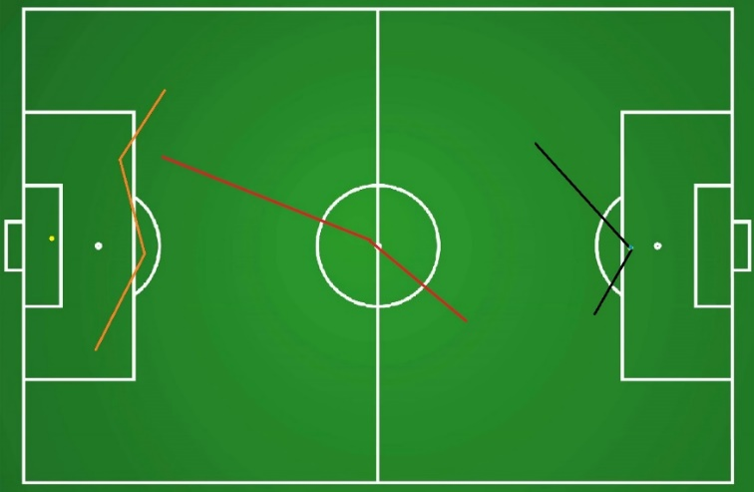
In this figure, the yellow point on the left side of the ground refers to the goal keeper. The orange line refers to the rear guard line which is consist of defenders. The red line refers to the middle guard line which is consist of midfielders. The black line refers to the forward line which is consist of forwards. The blue point on the right of the picture is the ball.

Pass Data
Table 6 : Pass data
Name | $$S_{p}^{pass_{sus}}$$ | $$S_{p}^{pass}$$ | $$R_{p}^{pass}$$
Huskies_G1 | 473 | 777 | 60.88%
Huskies_F1 | 238 | 362 | 65.75%
Huskies_D1 | 851 | 1090 | 78.07%
Huskies_M1 | 1255 | 1526 | 82.24%
Huskies_F2 | 859 | 1120 | 76.70%
Huskies_D2 | 580 | 718 | 80.78%
Huskies_M2 | 76 | 97 | 78.35%
Huskies_M3 | 887 | 1074 | 82.59%

Firstly, we count all the passing events through the file passingevents.csv. There are two types of passing events: successful passing event and passing event. Successful passing event means a teammate get the ball after passing:
$$S_{p}^{pass_{sus}}=\sum_{p_{2}∈T_{p}}{C_{P_{p,p_{2}}}}$$
Passing event:
$$S_{p}^{pass}=\sum_{p_{2}}{C_{P_{p,p_{2}}}}$$

Table above is data of first ten Huskies players. We also count data of other teams. Then we use the formula:
$$R_{p}^{pass}=\frac{S_{p}^{pass_{sus}}}{S_{p}^{pass}}*100\%$$
to calculate the ratio of player $p$’s passing success. This concerns as one of the indices to evaluate the individual ability of players.

Duel Data
Table 7 : Duel data
Name | defend | $${defend}_{sus}$$ | attack | $${attack}_{sus}$$ | $$S_{p}^{duel}$$ | $$S_{p}^{duel_sus}$$ | $$R_{p}^{duel}$$
Huskies_G1 | 16 | 8 | 27 | 14 | 43 | 22 | 51.16%
Huskies_F1 | 433 | 47 | 464 | 185 | 897 | 232 | 25.86%
Huskies_D1 | 82 | 11 | 501 | 129 | 583 | 140 | 24.01%
Huskies_M1 | 166 | 24 | 563 | 148 | 729 | 172 | 23.59%
Huskies_F2 | 173 | 21 | 318 | 92 | 491 | 113 | 23.01%
Huskies_D2 | 43 | 8 | 309 | 101 | 352 | 109 | 30.97%
Huskies_M2 | 10 | 1 | 36 | 10 | 46 | 11 | 23.91%
Huskies_M3 | 83 | 19 | 404 | 123 | 487 | 142 | 29.16%
Then we count all the dueling events through the file fullevents.csv. There are four types of dueling events: defending dueling event (defend), successful defending dueling event (${defend}_{sus}$), attacking dueling event (attack) and successful attacking dueling event (${attack}_{sus}$). Defending dueling event means a teammate tried to defend opponent’s attacking dueling, while successful attacking dueling event means that a player tried to duel the opponent and succeed. Table above is the data about the first eight players of Huskies. We also count the data of all the other players. Then we use the formula
$$sum=defend+attack$$
$${sum}_{sus}={defend}_{sus}+{attack}_{sus}$$
to calculate the total number of players dueling events and successful ones. These two concerns as one of the indices to evaluate the individual ability of players. We use the formula
$$R_{p}^{duel}=\frac{sum}{sum_{sus}}*100\%$$
to calculate the ratio of player $p$’s dueling success. This concerns as one of the indices to evaluate the individual ability of players.

Team Formations
Table 8 : Huskies team formation
name | count | win | lose
4-3-3 | 12 | 5 | 4
5-3-2 | 5 | 1 | 3
4-4-2 | 13 | 4 | 4
5-4-1 | 2 | 1 | 1
4-5-1 | 5 | 1 | 3
4-2-4 | 1 | 0 | 0
We calculate the number of defenders, midfielder, forwards in all 38 matches for each team. Table above shows Huskies formation data. Ties are neglected.
In soccer, a team formation is usually written like x-y-z, where x, y, z are all digits, which means that the number of defenders is x, the number of midfielders is y and the number of forwards is z.
It is denoted that we only count the formation team used in the beginning of each match. We do not concern the influence of substitutions.
Here is a significant problem about opponent teams’ data. We have only two matches data of one specific opponent team and both matches are against Huskies. It's difficult to accurately measure other teams' indicators with a small amount of data. The insufficient data includes passing and dueling data mentioned above, also the data about team formations discussing now, and other data mentioned later.

Side Data
Table 9 : Huskies side data
Side | Win | Tie | Loss
Home | 10 | 4 | 5
Away | 3 | 6 | 10
In this part we count the result of each team in different side. From this example table, we see Huskies won ten times home side while three time away.
T-test shows that they have more possibility to win at home than away from home, with $p<0.01$.

Same Opponent Data
Table 10 : Huskies same opponent data
Match | Win2 | Tie2 | Loss2
Win1 | 3 | 1 | 3
Tie1 | 2 | 2 | 1
Loss1 | 1 | 2 | 4
We count the result of Huskies against the same opponent. When Huskies against the same opponent twice, The event that Huskies won in the first match but lost in the second match occurs 3 times in the whole data. And the event that Huskies lost at first but won in the second match occurs just once.
Chi Square test shows the probability of Huskies win and the result of the first game are not independent, with $χ^{2}<0.01$. The result of first match will influence the second one against the same opponent.
If they can improve their mental abilities, they will have more chance to win in the second match when they have won for the first time.

Structural Tactics
Firstly, we manually find out some structural tactics from the crucial chains.

Figure 3 : Example of crucial chains
As the figure shows above, Huskies often attack after dueling near the penalty box by kicking the football directly passing center line, instead of short pass. When the ball is in the opposing half, they often pass short instead of long. As for the tactics, they constantly dribble chaperonage of short passing, and waiting for the shot. They usually cross and pass in a wide range. Huskies mainly attack in the middle and less attack from the side. In further games, they may use more side attack to score more efficiently.
In conclusion, we find two main attack tactics of Huskies:
The first tactic is Counter Attack, which means the defenders duel positively. Once get the ball, the defender will try to high pass to midfielders or forwards immediately. Then the forwards will finish shot quickly. It is a powerful tactic because the attack is too fast for the opponent defenders to resist. To identify this kind of tactic, we consider the Position Network. Here is an example of Counter Attack in Position Network:
Figure 5 : Counter Attack
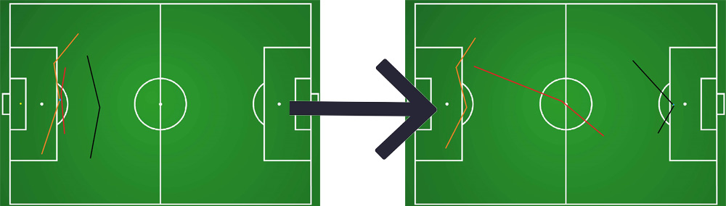
The figure above is made of two Figure 4 : Example of position network.
In this figure, we find the Counter Attack usually causes the forward line and midfielder line shift to the right and always starts at the dueling event near our gate, and it cost little time to finish shot. So, we consider it as a Counter Attack when it meets the following three requirements:
- Start mark. Duel success near our gate.
- Push forward. The midfielder line and forward line go right.
- Short time. From dueling event to shot event, it costs no more than 3 minutes.
The second tactic is Short Pass, which means forwards and midfielders pass to each other shortly while getting close to the gate and shoot. No high pass or head pass. So, we consider it as a Short Pass when it meets the following three requirements:
- Short pass. Each pass is short enough. No cross pass, etc.
- Close to shoot. Each pass should get close to the gate.
- Enough passes. At least 5 pass events.
We count the number of these two tactics:
Table 11 : Tactics count
Tactics | Performed | Succeed | Ratio
Counter Attack | 903 | 131 | 14.51%
Short Pass | 1874 | 76 | 4.06%
According to the data, Counter Attack is more efficient than Short Pass, though Huskies use Short Pass more often than Counter Attacks.
We admit there are other tactics in soccer, but it is hard for us to summarize the characteristics of all the tactics because of sufficient data. Meanwhile, there are some defensive tactics that we have dismissed. And we also dismiss rarely-used tactics because we believe tactics should be effective and hard to counter.

Identify Indicators
We divide performance indicators into 3 parts: players, teamwork and team, listed below:
Table 12 : List of indicators
Players | Teamwork | Team
Pass success rate | Local collaboration | Team formation
Duel ability | Crucial chain | Flexibility
Other abilities(ignored) | Structural tactics | Mentality

Player Ability
Players’ abilities include pass success rate, duel ability and other abilities, among which we neglect other abilities because we do not have enough statistics both of Huskies and the opponents. As the two indices are of nearly the same importance, they share the same importance ratio. However, good players should account for a larger proportion of the team, as he has more chance to lead off an attack, which may change the outcome of the game. For instance, among the players listed in Huskies’, player Huskies_F2 takes part in most of the attacks, result in his outstanding ability.

Collaboration & Crucial Chain
The dyadic and the triadic configurations play a significant role, also defined as crucial chain in teamwork and they have a huge effect on the outcome of a game. Appropriate cooperation can motivate players so that they can reach their goals better and faster in teamwork. In other words, suitable chain can maximize players’ ability and performance in perfect unison, just like a “golden pair”.

Tactics
Different from local collaboration, a tactic is a strategy for the whole team. Tactics include the attack chain’s actions and moreover influence the flow of matches as well as the outcome of a game. Tactic can control the flow of a match, for instance, team can attack actively when fell behind and shrink defend when in the lead. Moreover, a team can use suitable tactics to earn more goal difference and get a better rank in the season.

Flexibility
We want to take Table 10 : Huskies same opponent data as the resource of team’s flexibility. When meeting an opponent, a team will adopt a more targeted and effective strategy to deal with. The more flexible a team is, the greater chance it has to win again or maintain tie or turn the tables. The less flexible a team is, the greater chance it has to turn victory to defeat or tie.
We also think that during one match, if the opponent always uses same tactics to attack, the ratio of successful defend should be higher because of the rich experience. But we fail to count it because it is hard to identify specific tactics.

Mentality
We consider Table 9 : Huskies side data to measure the ability to control mentality of one team. In soccer, the home advantage is very important. One team have more chance to win home than win side even facing same opponent, because of the fans, environment and even judges. So, with pressure from fighting away home, the better ability to control mentality a team has, the more chance it has to win away.

Team Formation
A soccer team is consisted of 4 parts: Forwarder (F), midfield (M) , defense (D) and goal keeper (G) . In a soccer team, we often use 4-4-2 or 4-4-3, etc. Opposing to various opponents makes us use different formations to get a higher probability to win. If we put appropriate player on all of the right position, the team will function more effectively and efficiently. In most cases, a team should put their best players in their starting line-up. However, when facing different opponents, a team should adopt different formations to get a better outcome.

Model
Among the 3 part of indicators, including single player’s ability, teamwork (including local collaboration and crucial chain) and strategies of the whole team, we give the individual’s ability the most weight, because we believe each small move brings the victory. Then comes the cooperation on a small scale, such as collaboration of 2 or 3 players. At last, although team tactics and mentality affect the result, they won’t share much significance in our model.
Our model includes 3 parts, structural, configurational and dynamic aspects.

Structural Aspect
We consider ability of first eleven formation addition with three reserve players as structural ability score of a team which we denoted as$SA$.
$$SA=PDA+PMA+PFA+PGA+PTA+PCA$$
PDA is the ability score of defenders. PMA is the ability score of midfielders. PFA is the ability score of forwards. PGA is the ability of goal keeper. PTA is the additional ability score from local collaboration. PCA is the crucial player additional ability score.
Data is from $REF _Ref32727012 \backslash h$Table 6 :, Table 7 : Duel data, Table 4 : Top ten dyadic of Huskies, Table 5 : Top ten of Huskies triadic group and Figure 3 : Example of crucial chains.$$A_{p}=（R_{p}^{pass}+R_{p}^{duel}）*\left(S_{p}^{pass}+S_{p}^{duel}\right)$$
$A_{p}$ is the ability score of $p$, $(R_{p}^{pass}+R_{p}^{duel})/2$ is the average of ratio in two basic events. $\left(S_{p}^{pass}+S_{p}^{duel}\right)$ is the number of main events which influences the ball most. By multiply these two, we get the number of effective interference ball event from $p$. Denote that $A_{p}$ must be a data per game.
$$PDA=\sum_{i=1}^{5}{A_{p_{i}}} Position\left(p_{i}\right)='Defender'$$
PDA is the sum of top 5 defenders ability score. Because normally there won’t be more than five defenders on the field.
$$PMA=\sum_{i=1}^{5}{A_{p_{i}}} Position\left(p_{i}\right)='Midfielder'$$
PMA is the sum of top 5 midfielders ability score. Because normally there won’t be more than four midfielders on the field.

$$PFA=\sum_{i=1}^{4}{A_{p_{i}}} Position\left(p_{i}\right)='Forward'$$
PFA is the sum of top 4 forward ability score. Because normally there won’t be more than four forwards on the field.
$$PGA=OppShot*1000$$
OppShot is the number of opponent’s shot event. consider this is very important event for the game, give it weights huge.
$$PTA=\left(Triadic*2+Dyadic\right)$$
Triadic is the count of triadic configurations and dyadic is the count of dyadic cooperation. Each triadic configuration contains two successful passes while dyadic has one.
$$PCA=\sum_{p∈Crucial}{A_{p}}$$
$Crucial$ means a set of players who shows in over 5 different crucial chains.

Configurational Aspect
Configurational aspect is about the team’s strategy and the personnel arrangement.
We take structural tactics data and the substitution data and formation data to measure this configurational ability score (CS) from Table 8 : Huskies team formation and Table 11 : Tactics count.
$$CS=SS+AS$$
SS is strategy ability score. AS is arrangement score.
$$SS=CounterAttack * 5+ShortPass*15$$
$CounterAttack$ is the count of Counter Attack executed successfully. Once executing Counter Attack, about five events influence the ball.$ShortPass$ is the count of Short Pass executed successfully And once executing Short Pass, about 15 events influence the ball.

$$AS=\sum_{f}{{FS}_{f}*winrate(f)}$$
$f$ is one kind of formation. $f∈\{433,532,442,541,451,424\}$ , ${FS}_{f}=\sum_{ i∈f}{{SA}_{i}}$. $winrate\left(x\right)$ is the ratio of win using formation x.

Dynamical Aspect
We define dynamical aspects as the flexibility and mentality.
$$DN=FL+MN$$
$DN$ is dynamical ability score. Flexibility data and mentality data are taken to measure dynamical aspects. We use $FL$ to measure flexibility and $MN$ to measure mentality.
$$FL=Win_away-Loss_home$$
$Win_away$ means the frequency a team win away from home and $Loss_home$ means the frequency a team loss at home, listed in Table 9 : Huskies side data.
$$MN=(Win2_Tie1+Win2_Loss1*2+Tie2_Loss1)-(Tie2_Win1+Loss2_Win1*2+Loss2_Tie1)$$
The variables above are in Table 10 : Huskies same opponent data.

Teamwork Evaluation

Result of Three Aspects for Huskies
Table 13 : Ability top five player
name |  |  | A | A_ave
Huskies_M1 | 105.84% | 2255 | 2386.5819 | 62.804787
Huskies_M3 | 111.75% | 1561 | 1744.36388 | 45.904313
Huskies_D1 | 102.09% | 1673 | 1707.91746 | 44.945196
Huskies_F2 | 99.71% | 1611 | 1606.33914 | 42.272083
Huskies_D3 | 99.58% | 1302 | 1296.48459 | 34.118016
Use Table 12 to calculate PDA, PMA, PFA and PGA for Huskies, which is calculated from Table 6 : Pass data and Table 7 : Duel data.

Table 14 : Count for Triadic and Dyadic
 | Triadic | Dyadic
Times | 360 | 2023
Times_ave | 9.47 | 53.23
Use Table 13 to calculate PTA for Huskies, which is calculated from Table 4 : Top ten dyadic of Huskies and Table 5 : Top ten of Huskies triadic group.
Table 15 : Crucial player
Name | Count
Huskies_F2 | 21
Huskies_F1 | 20
Huskies_F3 | 10
Huskies_M6 | 10
Huskies_F4 | 8
Use Table 14 to calculate PCA for Huskies, which is calculated from crucial chain data.
Table 16 : Huskies structural aspect
 | Structural Aspect
Name | PDA | PMA | PFA | PGA | PTA | PCA | SA
Huskies | 166.54 | 182.03 | 101.69 | 24.17 | 72.17 | 121.99 | 668.58
Table 15 shows the detail of SA in Huskies, which is calculated from Table 13 : Ability top five player, Table 14 : Count for Triadic and Dyadic and Table 15 : Crucial player.
Table 17 : Formation data for AS
Name | 433 | 532 | 442 | 541 | 451 | 424
FS | 370.06 | 382.26 | 385.67 | 382.24 | 366.89 | 352.99
FS_ave | 9.74 | 10.06 | 10.15 | 10.06 | 9.65 | 9.29
winrate | 0.42 | 0.20 | 0.31 | 0.50 | 0.20 | 0.00

Use Table 17 to calculate the AS for Huskies, which is calculated from Table 17 : Formation data for AS.
Table 18 : Huskies configuration aspect
 | Configurational Aspect
Name | SS | AS | CS
Huskies | 47.24 | 16.15 | 63.39
Table 18 shows the detail of CS in Huskies, which is calculated from Table 11 : Tactics count and Table 17 : Formation data for AS.
Table 19 : Huskies dynamical aspect
 | Dynamical Aspect
Name | FL | MN | DN
Huskies | -2.00 | -2.00 | -4.00
Table 19 shows the detail of DN in Huskies, which is calculated from Table 9 : Huskies side data and Table 10 : Huskies same opponent data.
Table 20 : Huskies teamwork evaluation
Name | SA | CS | DN
Huskies | 668.58 | 63.39 | -4.00
We also use our model to evaluate the other 19 teams. The rank of three aspects below:
Name | SA | CS | DN
Huskies’ rank | 5 | 7 | 12
Among the three aspects, Huskies’ structural ability is ranked 5th, which is benefited from their outstanding players and crucial chains. Configurational aspects is equally excellent because of their active duel and attack. Unfortunately, their dynamical ability isn’t such good, for instance, they cannot change their strategies to fight against a team which they were defeated by and their mental ability aren’t such stable which led to poor win rate when fighting away from home.

Suggested Formation
We suggest the coach choose 4-4-2 formation. The suggested starting line-up players’ names are listed below and these 10 players share the top ten grades in our model.
Table 21 : Suggested formation members
Huskies_M1 | Huskies_M3 | Huskies_D1 | Huskies_F2 | Huskies_D3
Huskies_D5 | Huskies_D2 | Huskies_M6 | Huskies_F1 | Huskies_M4
If these players could play at the position they are familiar with, they will have a better performance. The suggested starting line-up is shown below:
Figure 6 : Suggested formation line-up
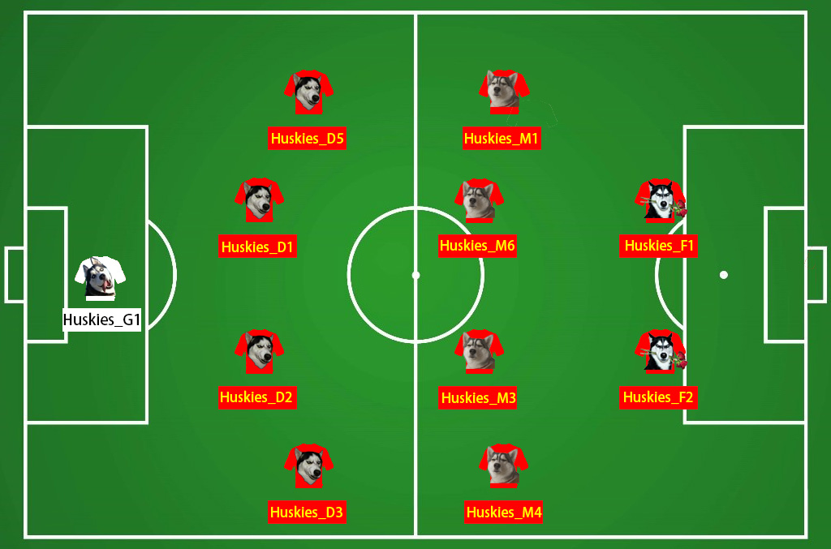
We also evaluate this formation with our model and the statistics are listed below. The score is higher than any other formations.
Table 22 : Formation evaluation
SA | CS | DN
679.82 | 893.73 | -1
As for substitute line-up, the top players should be considered first. The suggested players to substitute are listed below:
Table 23 : Suggested substitutes
Defenders | Midfielders | Forwarders
Huskies_D4 | Huskies_M12 | Huskies_F6
Huskies_D7 | Huskies_M9 | Huskies_F4
Huskies_D6 | Huskies_M8 | Huskies_F5
We choose this formation not only because the formation shares a high winning rate, but also the top 10 players (the only goalkeeper appeared in data is ignored) are also in the name list with many dyadic and triadic configurations and crucial chains. As Table 4 : Top ten dyadic of Huskies and Table 5 : Top ten of Huskies triadic group show, the top three dyadic configurations and the top ten triadic groups are all in this formation. Among all the formations, this formation share the highest score and we sincerely suggest the coach to choose these players and train them to win more matches in the future.

Advice to Coaches
Firstly, we recommend that it is important to maintain their outstanding players, such as F2 who stands at the top of Table 15 : Crucial player, to keep their personal ability, because this kind of crucial player not only contributes to the PFA, but also contributes to PTA and PCA. In conclusion, their ability matters more than other common players. In this case, we eagerly suggest the coaches could done things following:
1. Prevent star players from being poached, especially Huskies_F2, Huskies_F1 and Huskies_M6.
2. Buy a capable midfielder. Because there is only one crucial midfielder, Huskies_M6. We believe one more good midfielder could create more chance to efficient attack.
3. Train the ability to duel for the midfielders. From crucial chains, we see that few attacks starts at the middle of field.
Then, we think it should be helpful to use more familiar team formation instead of using various formations. Because from Table 8 : Huskies team formation and Table 17 : Formation data for AS, we find out that the more times a formation is used, the higher ratio of wining is. Besides, the sum of personal ability score of this formation is also higher. For example, 4/4/2 formation is the most used one and having the highest win rate and the best formation ability. To achieve this goal, we suggest:
4. Train the players more times when less-used formation is going to be used.
5. Be careful when changing formation. Do more research on the opponent’s strategies and choose formation accordingly. Request experts when necessary.
We also notice how structural tactics influence the evaluation. When a tactics is performed, we expect it be efficient. For example, Count Attack is more likely to have a shot than Pass Short. In our opinion, both tactics should be improved but in different aspects. Besides, efficient tactics should also be introduced:
6. Make Count Attack have more chance to perform. For example, try to improve the midfielder’s ability to duel. Once midfielders get the ball, the Count Attack should also be performed quickly and efficiently. It would be more deadly when starting Counter Attack strategy in middle field because of closer to opponent’s gate.
7. Make Short Pass have more chance to shoot. Train the forward passing while be dueled more. Arrange more midfielders join the Short Pass strategy.
8. Introduce new efficient tactics. Ask experts for recommendation.
At last, it is hard for the team to control their mentality, which becomes a big weak point. Team cannot reach the average mentality control level of the league teams. They should obtain stable nerves to prevent them from mood swings, then earn more winning records away. To overcome this weak point:
9. Ask phycologist for help, especially in how to improve the confidence and unite of the team. Hire a psychological consultant to strengthen the team's mentality, in order to make the team set a higher winning rate when playing away from home.
10. Make the players more familiar with their opponent's field by adaptive training in advance. It is also helpful that encouraging fans going to the away field to accompany with team.
11. Let the star players, such as F2 to drive other team members to fight for their team actively.

Team in Society

Indicators
When it comes to social teams, we consider the indicators are just like the factors in a soccer team. Personal ability, small-range collaboration and the whole team’s corporation are the main indicators that influence a team’s performance. Only when we consider all the three aspects can we form a successful team.
The team members’ single capability plays a significant role in a team, especially the star members. An excellent person can contribute to the team on a large scale, becoming the decisive factor of a team, just like a capable forwarder in a soccer team. A great team member can also enhance the cohesion of team members, inspiring them to be more diligent. As for abilities, there are many kinds of abilities, each of which has an irreplaceable status. A successful team should own various talented individuals to solve distinct problems. In addition, a person with special ability is indispensable even if the team is not in need of him at present.
Some work should be accomplished by several people so their corporation becomes much crucial. When some suitable people cooperate, they have great power to solve any complex problem, just like crucial chains in a soccer team.
From macroscopic aspect, a team formation can influence their performance. Putting appropriate person on his right position can make the team work efficiently, not wasting anybody’s ability. Flexibility and mentality can change team members’ attitude toward a specific thing. Appropriate inspiring measures can cultivate team members’ potential, leading to their better outcome of the work.

Other Aspects and Indicators
Except for the above factors that can calculate a team’s performance, there are many other aspects can influence team’s power.
A good team leader, just like the coach of a soccer team, can change the team to the great extent. If the leadership can formulate an appropriate policy, the team members will be inspired and maximize their capacity to finish the work efficiently.
Team members’ cohesive force is crucial to successfully finish their work. To enhance this, we suggest the leadership often consider the subordinates’ mood and make targeted plans for each of them. In a soccer team, the club superintendent should maintain their star players, preventing them from being transferred to other teams.

Advice to Team Leadership
  - Hire or recruit more capable person and offer them higher salary to make them faithful to the team without switching jobs, just like trying best to keep Huskies_F2 in team.
  - Let the capable person drive and encourage other team member to work in the right way and achieve their goals. This will help the team maintain good mentality.
  - Keep team member united and cooperate with each other. Because an efficient cooperation will inspire team members to exert their abilities.
  - Evaluate every team members’ ability and set suitable aims for everybody. Pick the top team members to be the core of team, like leadership, leaders in small work groups, doing kernel work.
  - Be careful when changing working mode to prevent the team from being in chaos. A stable efficient old working mode is much reliable than an uncertain new mode. Work efficiency increases as familiarity with working methods, just like 4-4-2 formation in Huskies which has both highest winning rate and used times.

Evaluation and Promotion of Our Model

Strengths
Our model takes many factors into consideration, which can measure a team’s performance accurately. We divide the factors into three aspects from micro view to macro view, containing structural, configurational and dynamical aspects. Each of the parts contains three variables, calculated by statistics in the given data.
Our model has strong applicability. The model is applicable for any teams and any games to evaluate themselves and improve their performance purposefully with only data of matches.
Our model not only apply to soccer teams but can also be extended to social teams, such as companies and clubs to guide their plans and reach their goals well.

Weaknesses and Promotion
Our model neglects some events in the raw data, such as fouls and substitution. We cannot match shots to goals because we do not have data of goal time. Moreover, fouls cannot reflect a player’s ability because different player has different to foul and some fouls are tactical. Some other events share a few occurrences and we do not know the result of each event. What’s more, the changes of coaches are not discussed in out model because we cannot found the changes of team patterns. If we have more data, we can improve our model by adding new aspects and factors to the evaluation model.
We lack corresponding knowledge of soccer so we cannot discriminate much tactics from the data. If we have had more knowledge of characteristics of soccer tactics, we could discriminate more tactics from the data and evaluate a soccer team’s performance diversified. Or if we have had more data of all events we could use neural network to identify more patterns of a team’s tactics and add them to the evaluation model.
Personnel change isn’t reflected in our model because there’s only one season’s data given. If we can obtain the players’ changes, we can make a targeted player-selection plan to improve the team’s abilities from many aspects.

References
[1] http://www.comap-math.com/mcm/2020_Problem_D_DATA.zip
[2] https://en.wikipedia.beta.wmflabs.org/wiki/Association_football
[3] Barabási, A. L. et al. Evolution of the social network of scientific collaborations. Physica A 311, 590–614 (2002).
[4] Gyarmati, L. & Anguera, X. Automatic Extraction of the Passing Strategies of Soccer Teams. arXiv:1508.02171 (2015).
[5] Gonçalves, B. et al. Exploring team passing networks and player movement dynamics in youth association football. PLoS ONE 12, e0171156 (2017).
[6] Takes FW, Kosters WA, Witte B, Heemskerk EM. Multiplex network motifs as building blocks of corporate Networks. Applied Network Science. 2018; 3(39): 1-22.
[7] Katzenback JR, Smith DK (1993) The Wisdom of Teams. NY: Harper Bussiness.
[8] Hughes M, Franks I (2005) Analysis of passing sequences, shots and goals in soccer. Journal of Sports Science 23: 504–514.
[9] T. Reilly and A. M. Williams, Science and soccer. Routledge, 2003.
[10] Rosen S (1981) The economics of superstars. American Economic Review 71: 845–858.
[11] P. Cintia, S. Rinzivillo, and L. Pappalardo, “A network-based approach to evaluate the performance of football teams,” in Proceedings of the Machine Learning and Data Mining for Sports Analytics workshop, ECML/PKDD 2015, 2015.
[12] J. Hollinger, “The player efﬁciency rating,” 2009.

